DIGITAL MARKETING

Assignment 4- Create an email newsletter and posting it in blog

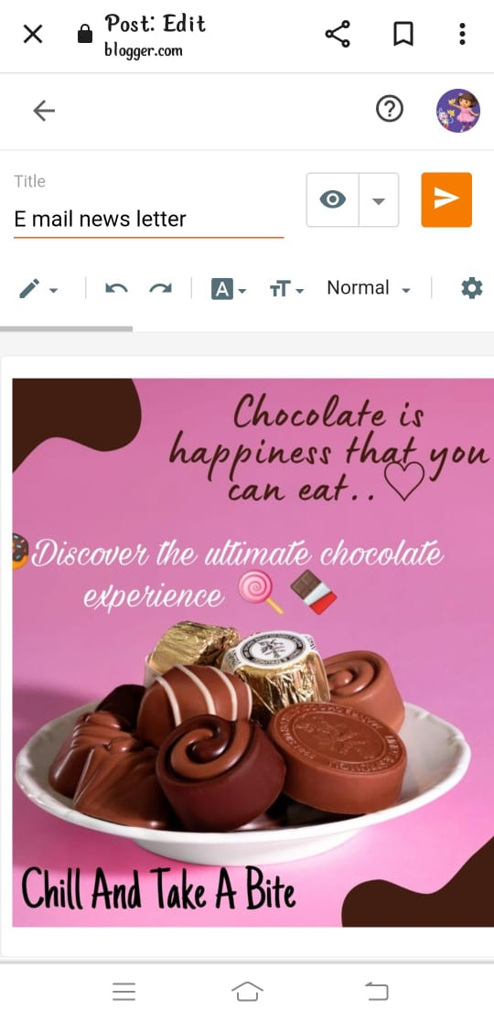

Figure: Post on blog

Email newsletter:

<https://www.blogger.com/blog/post/edit/5678674003426834245/5285219798354491482>

Email newsletter:

